**Exercises 1**

1. Create a variable named counter and set it equal to 0.
2. Create a while loop with the condition counter < 10.
3. The loop body should print out “counter is X” (where X is replaced with the value of counter) and then increment counter by 1.

void main() {

var counter =0 ;

while (counter< 10 )

{

print ('counter is X : $counter');

counter ++;

}

}

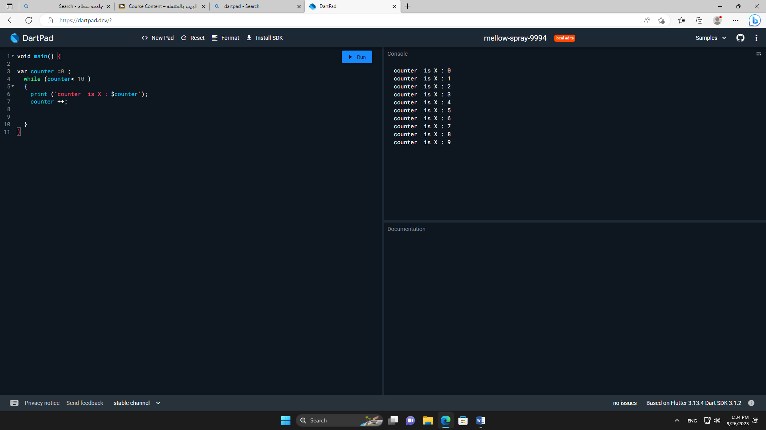

**Exercises 2**

1. Write a for loop starting at 1 and ending with 10 inclusive.
2. Print the square of each number.

void main() {

for (int i = 1 ; i< 10 ; i++ )

print ('square number : ${i*i}');

}

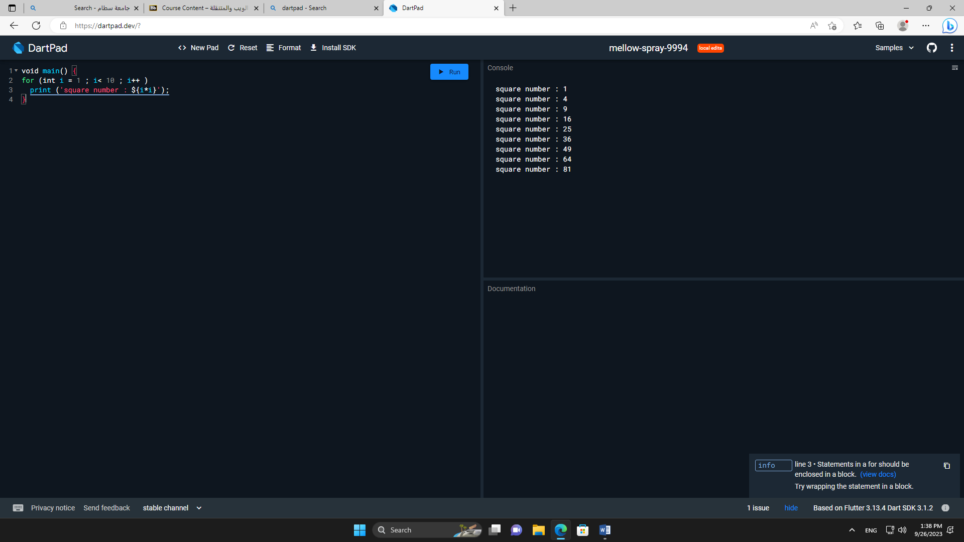

**Exercises 3**

1. Write a function named youAreWonderful, with a string parameter called name.

It should return a string using name, and say something like “You’re wonderful,

Bob.”

2. Add another int parameter to that function called numberPeople so that the

function returns something like “You’re wonderful, Bob. 10 people think so.”

3. Make both inputs named parameters. Make name required and set

to have a default of 30..

void main() {

print (youAreWonderful (name:'Bob',numberPeople : 10 ));

}

String youAreWonderful ({ required String name , int numberPeople = 30 })

{

return 'You’re wonderful,$name . $numberPeople people think so .';

}